Design Document

caXchange – ScenPro, Inc.
Ekagra

DOCUMENT CHANGE HISTORY
Version Number | Date | Contributor | Description
1.0 | 11/27/07 | Michael Holck | Initial Draft that describes the design of the elements included in the Elaboration phase
1.1 | 1/7/08 | Michael Holck | Added additional information about the components that are a part of the elaboration phase and some of construction phase I
1.2 | 1/8/08 | Kalpesh S. Patel | Added caXchange Hub design information.

Updated January 9, 2008

TABLE OF CONTENTS
1 Introduction 4
1.1 Purpose 4
1.2 SCOPE 4
1.2.1 caXchange Hub 4
1.2.2 Clinical Trial Object Data System (CTODS) Grid Services 4
1.2.3 CTODS Lab Viewer 4
1.3 Related documents 5
2 caXchange Design 6
2.1 caXchange Hub 6
2.1.1 Component View 6
2.1.2 Logical Design 7
2.1.2.1 caXchange Grid Service 7
2.1.2.2 caXchangeResponse Listener 7
2.1.2.3 caXchange Service Assembly 8
2.1.2.4 Sequence Diagrams 9
2.1.3 Data 11
2.1.4 Deployment 13
2.1.5 Test Cases and Scenarios 13
2.2 CTODS Grid Services 13
2.2.1 CTODS Grid Services Class Diagram 14
2.2.2 CTODS Lab Persist Grid Service Sequence Diagram 14
2.2.3 CTODS Register Subject Grid Service Sequence Diagram 15
2.2.4 CTODS Create Study Grid Service Sequence Diagram 16
2.3 CTODS Lab Viewer 17
2.3.1 Lab Viewer Login 17
2.3.1.1 Lab Viewer Login Class Diagram 17
2.3.1.2 Lab Viewer Login Sequence Diagram 18
2.3.2 Lab Viewer Query 19
2.3.2.1 Lab Viewer Query Class Diagram 19
2.3.2.2 Lab Viewer Query Sequence Diagram 20
3 Glossary 22

Introduction

Purpose
This Design document captures the software design for only the software components of the caXchange version 1.0. The overall goal of this project is to build a hub system that can adapt and extend data to multiple formats and whose value and usability can be pilot tested in one or more cancer centers. This includes a cancer center hub client to submit laboratory data to CTODS as well as a Lab Viewer application to view this data. The Lab Viewer will be interoperable with other CCTS applications.
This draft only captures the design of the components that will be developed during the elaboration phase and first construction phase iteration of this effort.

SCOPE
The scope of this document is limited to only the design of the caXchange components detailed in the following sections.

caXchange Hub
The caXchange Hub is the software component that is primarily responsible for receiving input from various external systems, routing the input to various services that are hosted on the hub, and eventually routing the output of those services to external systems. caXchange is implemented using Servicemix 3.1.2 enterprise service bus (ESB) for routing and exposing that functionality using a service deployed on caGrid. caXchange is deployed as a service assembly on Servicemix 3.1.2. caXchange grid service acts as a proxy to the service assembly.

Clinical Trial Object Data System (CTODS) Grid Services
The CTODS Grid Services is a collection of grid services used to persist data into the CTODS database. The CTODS Grid Services persist the HL7v3 Laboratory Observation Periodic Report message, as well as the C3PR v2.0 Patient Registration message and C3PR v2.0 Study creation message. The participant data from this message will be persisted into the CTODS database and will be used to match up the identifier with the lab results that are also persisted in CTODS.

CTODS Lab Viewer
The CTODS Lab Viewer is a web based application developed by leveraging the SDK generated APIs of the Lab Domain UML model from the core caXchange effort. Building of this application adds substantial enhancement to caXchange and provides the complete the end to end caXchange solution. In the original caXchange v 0.5, laboratory data from a cancer center was being transformed, routed, and persisted into the CTODS database, but there was no visual and user friendly GUI tool to view the laboratory data that got stored in CTODS database. Based on the use cases identified by the SMEs of the CTMS Interoperability project, a new requirement was identified that made the viewing of lab data from CTODS a critical piece of the CTMS interoperability project.
The CTODS Lab Viewer allows users to view laboratory activities records that are stored in the CTODS database. Users will be allowed to search the laboratory activity records by Patient Id, Study Id, Lab Start Date, and Lab End Date. When the search results are displayed, numeric results that are outside the high and low reference ranges of the lab tests will be highlighted to alert the user. This visual alert/trigger will allow the user to focus in and act on those specific lab test results.
Additionally, the CTODS Lab viewer will allow users to send lab data to the local CDMS application (C3D). The functionality to select which labs should be loaded into the CDMS will be provided in the CTOM Lab Viewer interface.

Related documents
Table 1 Related Documents
Document Name | Version | Location
caXchange Use Case Specification and Realization Document | 1.0 | https://gforge.nci.nih.gov/plugins/scmcvs/cvsweb.php/caxchange/Deliverables/Use%20Case%20Specification%20and%20Realization%20Documents%20(Task%202.1).rtf?cvsroot=caxchange
caXchange Software Requirements Specification Document | 1.0 | https://gforge.nci.nih.gov/plugins/scmcvs/cvsweb.php/caxchange/Deliverables/Software%20Requirement%20Specifications%20(Task%202.2).doc?cvsroot=caxchange
caCORE 3.2_Tech_Guide (Chapter 10: Common Logging Module)
CSM – User Provisioning Tool User Guide |  | (ftp://ftp1.nci.nih.gov/pub/cacore/CSM/UPT_User_Guide.pdf)
Servicemix Documentation |  | http://servicemix.apache.org/documentation.html
Java Business Integration Specification |  | http://jcp.org/en/jsr/detail?id=208
caXchange Interface Specification |  | https://gforge.nci.nih.gov/plugins/scmcvs/cvsweb.php/caxchange/Documentation/Interface/caXchange_Interface_Specification.doc?cvsroot=caxchange
caXchange Design Diagram |  | https://gforge.nci.nih.gov/plugins/scmcvs/cvsweb.php/caxchange/Documentation/Design/reliable-messaging-diagram.odg?cvsroot=caxchange

caXchange Design

The design of the caXchange components are detailed in the following sections.

caXchange Hub

Component View
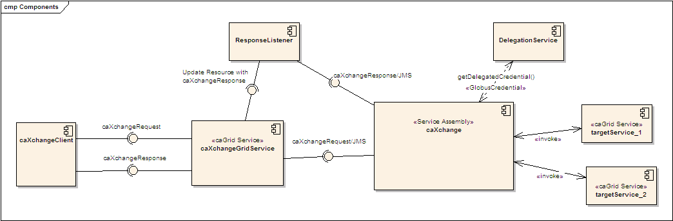
Figure 1 - caXchange Component View
Figure 1 shows the high level components in caXchange. Please refer to the caXchange design diagram for the components within the caXchange service assembly.
- A caXchange client sends a caXchangeRequest message to caXchangeGridService.
- caXchangeGridService is a caGrid service which acts as a proxy for the caXchange service assembly deployed on Servicemix JBI (Java Business Integration) Container.
- caXchangeGridService creates a WS-Resourceframework Resource associated with the caXchangeRequest. This caXchangeRequest is then forwarded to the caXchange service assembly for processing. This is done by pushing caXchangeRequest message to the jms inbound component of caXchange service assembly.
- caXchange service assembly then invokes the DelegationService for the authorization credentials before routing the request message based on the message type. Please refer to the caXchange detailed design diagram for routing details.
- Outbound components then invoke the target services.
- Responses from the target services are then composed into a caXchangeResponse message.
- caXchangeResponse is then pushed to the jms outbound component.
- The response listener then picks up the caXchangeResponse and updates the WS-Resourceframework resource created in step 3.
- The caXchangeResponse is then available to the client.

Logical Design

caXchange Grid Service
The caXchange grid service acts as a proxy for caXchange. It forwards incoming requests to caXchange for processing. To keep track of a request it creates a WS-Resource framework resource. The grid service then returns an EndPointReference to the client. The client uses this end point reference to invoke the getResponse operation. The grid service also creates a response listener, which listens for caXchangeResponse and updates the resource. Please see the caXchange Interface Specification document for details of the operations it exposes.
Operations
Table 2 - caXchange Grid Service Operations
Method | Notes | Parameters | Return
ProcessRequestAsynchronously | Process a caXchangeRequest | CaXchangeRequest | CaXchangeContextReference
getResponse | Gets the caXchangeResponse if it is ready, otherwise throws an Exception | None | caXchangeResponse

caXchangeResponse Listener
The caXchangeResponse listener lives with the caXchange Grid service. It listens for the response on the jms queue associated with the response outbound component of the caXchange service assembly. Once a response is received from the queue, the resource associated with the corresponding request is updated. The client can then use the getResponse method to get the caXchangeResponse.
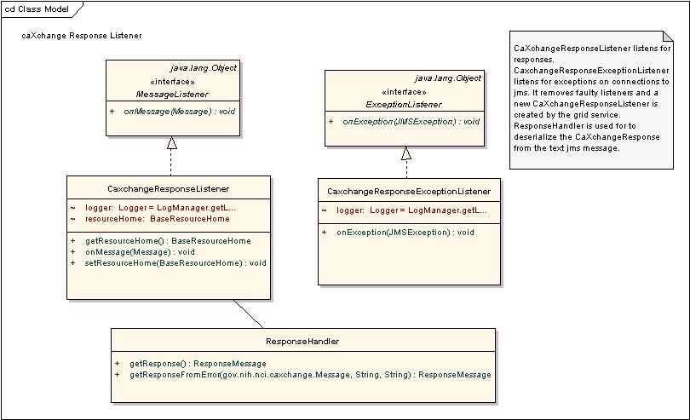
Figure 2 - caXchange Response Listener

caXchange Service Assembly
The caXchange service assembly is deployed on the Servicemix JBI container. The caXchange design diagram gives the detailed design of the caXchange service assembly.
Table 3 describes caXchange service assembly components. Numbers in the component column refer to the number in the caXchange design diagram given to an exchange going into that component.
Table 3 - caXchange Service Assembly Components
Component | Type | Purpose
1. InboundComponent | JMS | Receive inbound caXchangeRequest messages.
3. Invoke Delegation Service | Bean/EIP (Enterprise Integration Patterns) | This includes two components, a pipeline, which invokes a bean component that calls delegation service for authentication and authorization.
3. 3/4.3 Response Generator | Bean | Generates an error response
4. Save Message | Bean/EIP | This includes two components, a pipeline, which invokes a bean component that saves the message to a database. The saved message is used to contruct a response and/or sends a rollback.
5. Content Based Router | EIP | Routes the message based on the message type to a particular static recipient list.
6. Static Recipient List | EIP Customized | Sends the message to multiple recipients for invoking target services. This is customized to add a message property for number of recipients. This is used to aggregate responses
7. Content Based Router | EIP | Routes message based on operation. If the operation is process the message is routed to a pipeline to invoke the service and get a response as an in-out message exchange. If the operation is rollback the message is send without expecting a response as an in-only message exchange.
8.1. Pipeline | EIP | Pipeline to invoke target service as an in-out message exchange.
8.2. Outbound Component | Bean | Outbound component that invokes the target Grid Service.
8.4. Aggregator | EIP Customized | Aggregator component aggregates responses from multiple target services. This is customized to work with the customized static recipient list in #6 above.
9. Aggregator Listener | Bean | Aggregated responses from the aggregator are forwarded to this component, which does two things.  It looks at the response and the message type to verify if a rollback is required. If required a message with the rollback is sent to the content based router #5 after authentication and authorization by #3.  It creates a caXchangeResponse and sends it to the jms outbound binding component.
10. ResponseComponent | JMS | Outbound caXchangeResponse are pushed to this component.

Sequence Diagrams

Successful Flow Sequence Diagram
The sequence for a successful flow through caXchange is depicted in Figure 3. Detailed flow through the caXchange service assembly is depicted in the caXchange design diagram.
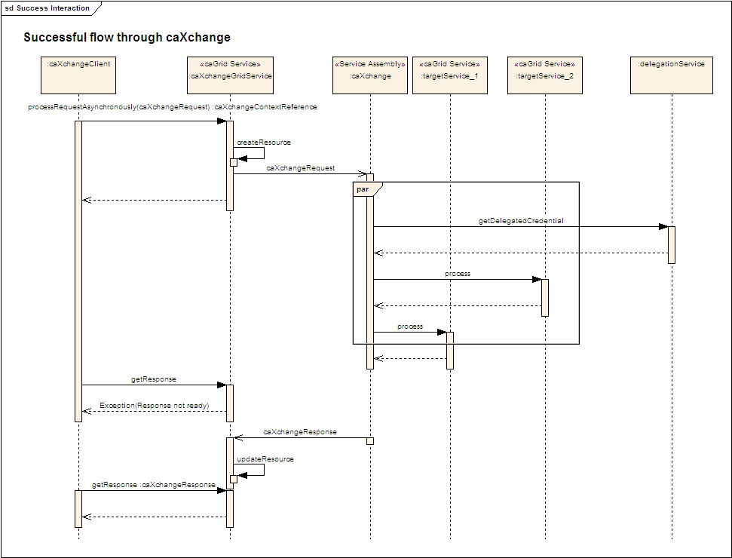
Figure 3 - caXchange Successful Flow Sequence Diagram

Rollback Flow Sequence Diagram
The sequence for a rollback interaction with caXchange is depicted in Figure 4. Detailed interaction within the caXchange service assembly is depicted in the caXchange design diagram.
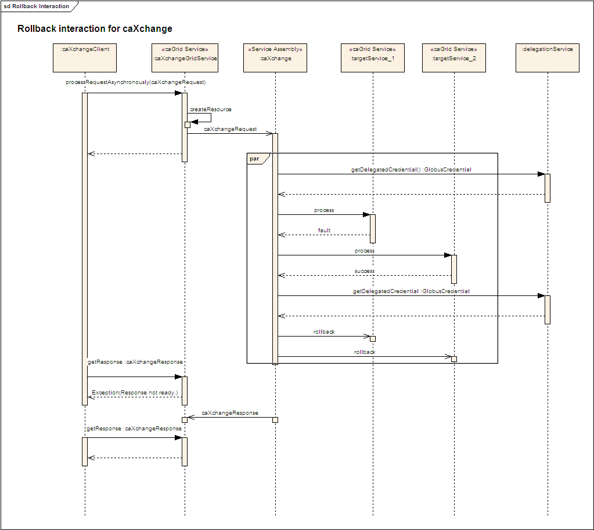
Figure 4 - caXchange Rollback Interaction Sequence Diagram

Data
A database schema will be created to facilitate saving the inbound caXchange request message for sending rollbacks and for creating aggregated/error responses.
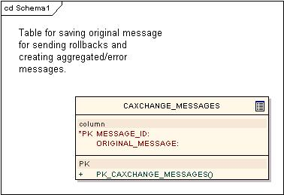
Figure 5 - Database Table for caXchange Messages

Deployment
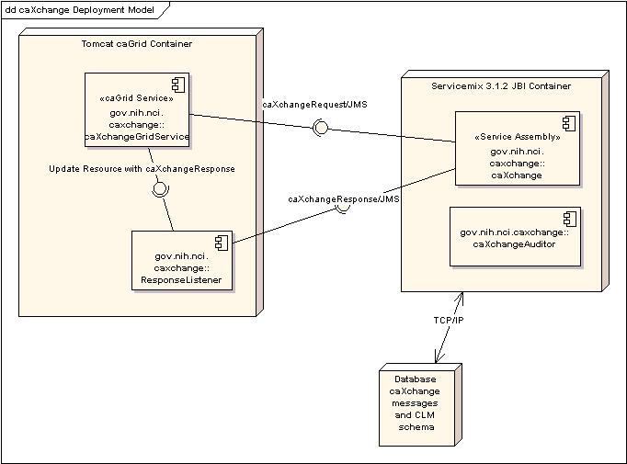
Figure 6 - caXchange Deployment Model

Test Cases and Scenarios
Please refer to the caXchange Testing Approach Document for test cases.

CTODS Grid Services
The CTODS Grid Service will be developed using the caBIG Introduce tool to generate the stubs and skeleton implementation. The following diagrams only reflect the classes that were implemented by the caXchange team for these services and do not include classes that were automatically generated by the Introduce toolkit.

CTODS Grid Services Class Diagram
The classes that implement the CTODS Grid Services are shown in Figure 7 below.
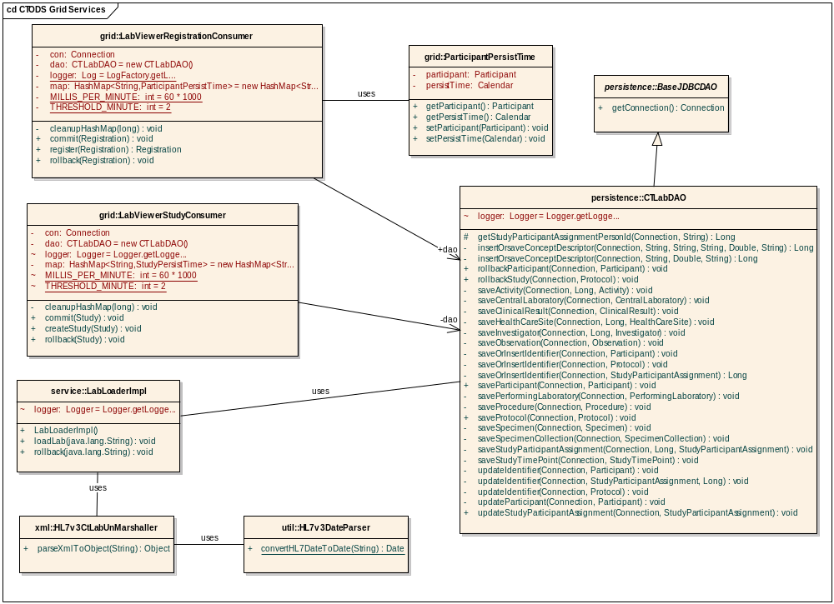
Figure 7 - CTODS Grid Services Class Diagram

CTODS Lab Persist Grid Service Sequence Diagram
The sequence diagram in Figure 8 below shows the sequence of events that occur when the caXchange hub calls the CTODS Lab Persist Grid Service. The string that is passed in to the loadLab method must be an HL7v3 CT Lab Message.
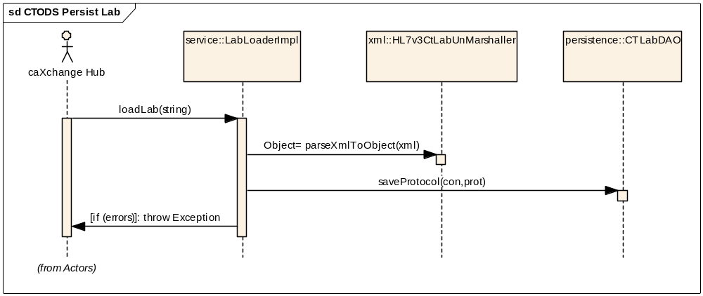
Figure 8 - CTODS Persist Lab Data Sequence Diagram

CTODS Register Subject Grid Service Sequence Diagram
The sequence diagram in Figure 9 below shows the sequence of events that occur when the caXchange hub calls the CTODS Register Subject Grid Service.
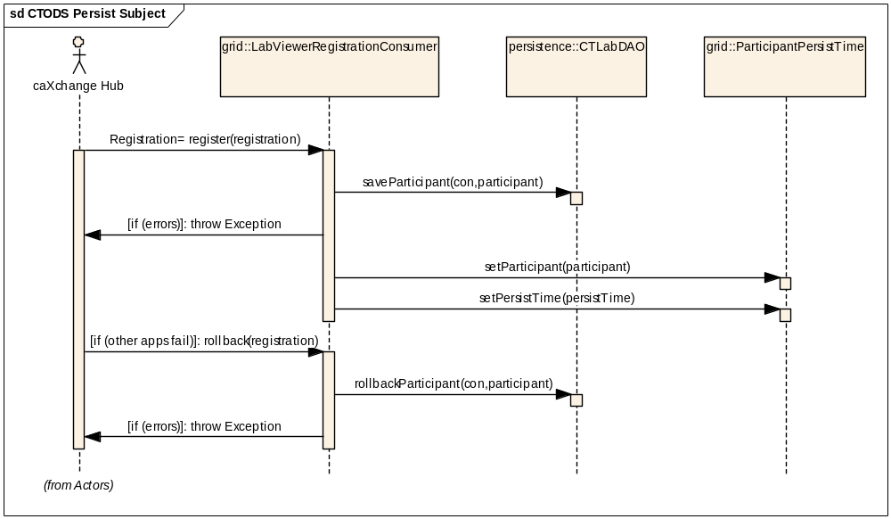
Figure 9 - CTODS Register Subject Sequence Diagram

CTODS Create Study Grid Service Sequence Diagram
The sequence diagram in Figure 10 below shows the sequence of events that occur when the caXchange hub calls the CTODS Create Study Grid Service.
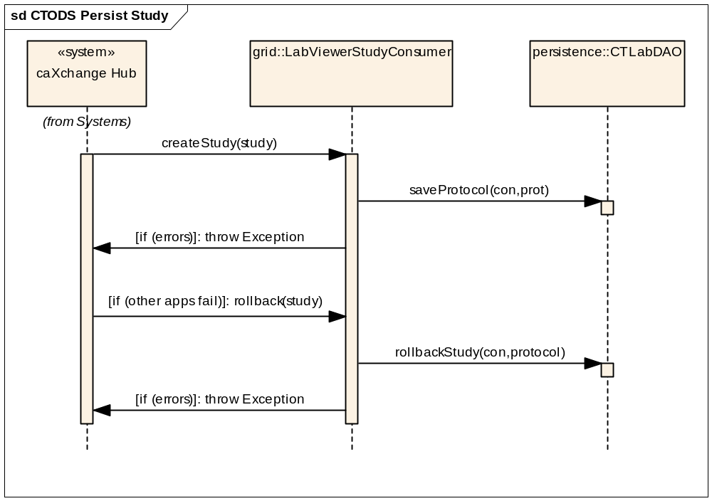
Figure 10 – CTODS Create Study Sequence Diagram

CTODS Lab Viewer
The CTODS Lab Viewer is a J2EE web application that uses the Struts framework. The actual implementation consists of several classes that include the actions, forms, and view objects and a single class diagram would be difficult to read. As such we will present the design in sections that implement the use cases of the system and only show the relevant classes for these.

Lab Viewer Login
The first use case that will be presented is the Login use case. This simply requires the user to login to the application and be authorized to use it. Lab Viewer uses the NCICB Common Security Module (CSM) for implementing authentication and authorization.

Lab Viewer Login Class Diagram
The classes that implement the Login use case are show below in Figure 11.
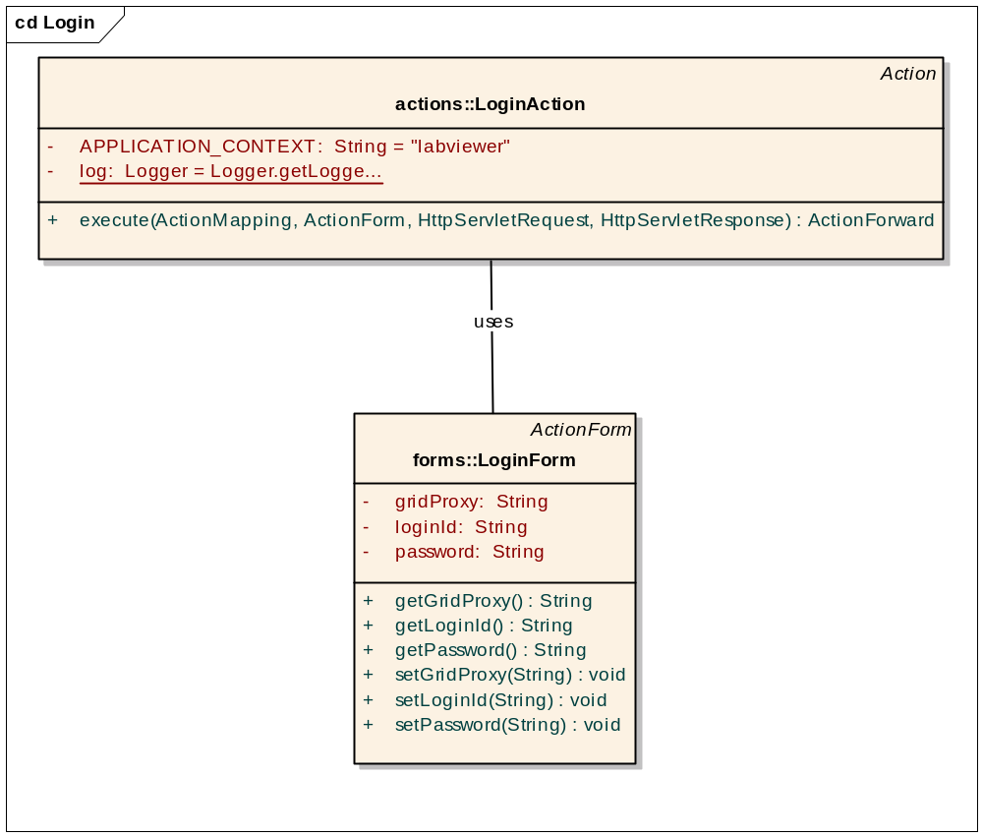
Figure 11 - Lab Viewer Login Class Diagram

Lab Viewer Login Sequence Diagram
The sequence diagram in Figure 12 shows the sequence of events that occur when the user logs into the application.
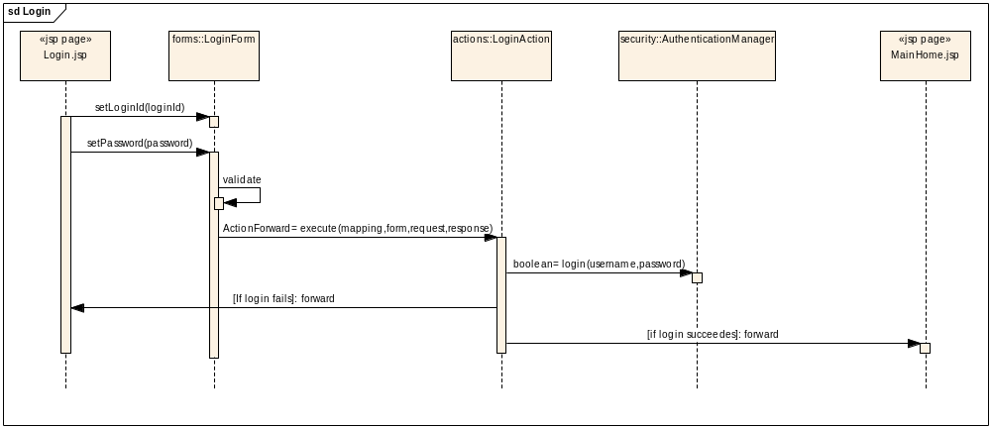
Figure 12 - Lab Viewer Login Sequence Diagram

Lab Viewer Query
The Lab Viewer Query use case involves a user searching the CTODS database for lab results and viewing the results.

Lab Viewer Query Class Diagram
The classes that implement the query use case are shown below in Figure 13.
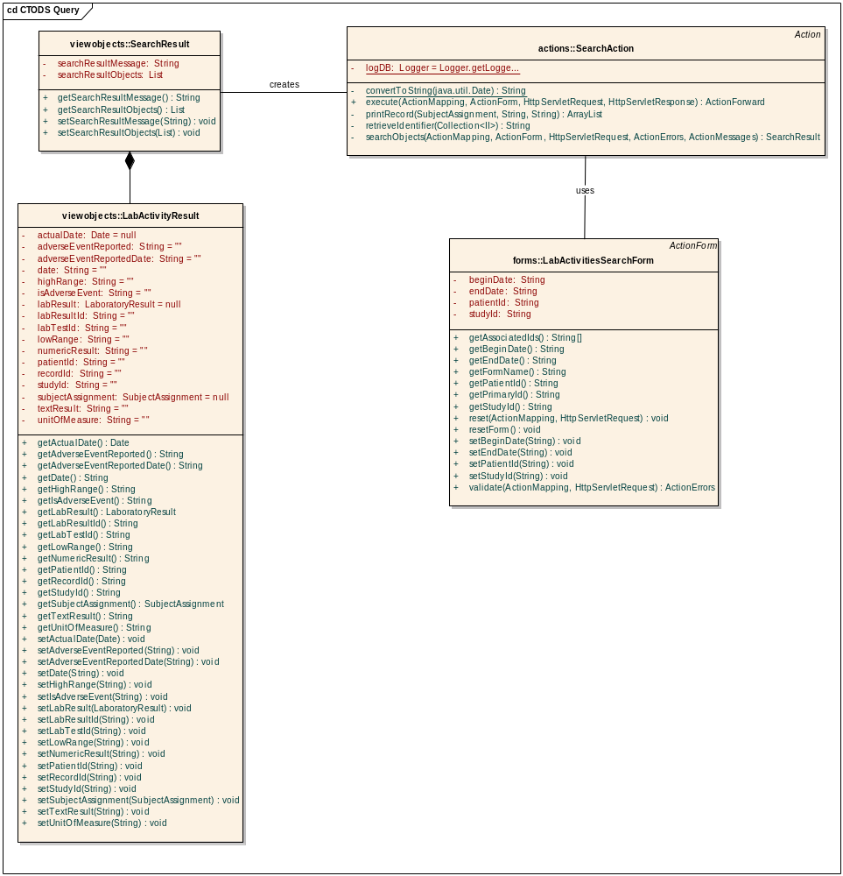
Figure 13 - Lab Viewer Query Class Diagram

Lab Viewer Query Sequence Diagram
The sequence diagram in Figure 14 shows the sequence of events that occur when the user queries for lab data.
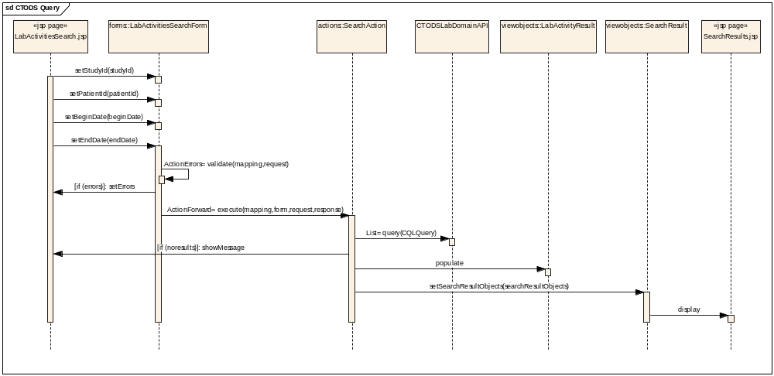
Figure 14 - Lab Viewer Query Sequence Diagram

Glossary
Term | Definition
NCICB | National Cancer Institute Center for Bioinformatics
BPEL | Business Process Execution Language
C3PR | Cancer Central Clinical Participant Registry
caAERS | Cancer Adverse Event Reporting System
GUID | A unique ID that the Enterprise Architect product assigns to each object that is created by the tool.
CCHC | Cancer Center Hub Client. The software that is responsible for sending patient laboratory data to the Lab Hub via an interface exposed by the HUB
Endpoint | A destination to which the hub can route data to. An endpoint can represent a service deployed on the hub or an external system to which the hub routes data.
CTMSI | Clinical Trials Management System Interoperability
CCTS | Cancer Clinical Trials Suite
CTODS | Clinical Trials Object Data System

caXchange Interface Specification
caXchange Interface Specification

